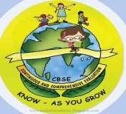
GREENWOOD PUBLIC SCHOOL, D.D. NAGAR
HOLIDAY HOMEWORK SESSION – 2020-21
CLASS – IX

SUBJECT - ENGLISH
- Write an article on the following topics:
[a] Covid -19 [b]Violence Among Youth
- Write a letter to M/s Sport King India Pvt.Ltd.placing an order for the order of sporting goods required by your school. You are Vinit /Vinita, Sports Secretary of the Ganga Public school, Paharganj New Delhi.(100-150 words)
- You have recently heard that Chennai is facing 'Day Zero' as it runs out of water and its underground aquifers. Gwalior also will face the same situation in a few years. Write a letter to the editor of a local newspaper on how we can work towards saving water to prevent ourselves from water crisis. You are Kavi/ Kavita ,resident of Patel Vihar ,Gwalior.(100-150 words)
- Describe following characters in your own words:
- Margie
- Tommy
- EvelynGlennie
- Ustad Bismillah Khan
Note: Complete Holiday Homework in A4 size papers.
SUBJECT – SCIENCE
- Learn and write all the terms of Chapter- Motion.
- Draw the graphs showing graphical representation of Motion.
- Derive the equations of Motion by using graphical method.
- Solve NCERT Q/A of Chapter- Motion.
- Prepare 1-1 topic each student for blackboard presentation in file from physics.
- 1. Prepare a file on different type of cell organelles with diagram and write its function and learn also.
- 2.Learn chapter 5 (fundamental unit of life)
- 3.Draw neat & clean labelled diagram of plant cell and animal cell
Multiple Choice Questions
Q1.Colour of copper sulphate crystal is:
a) Light blue b) Light green c) Light brown d) light yellow
Q2.When liquid air is heated then out of argon, nitrogen and oxygen:
a) Nitrogen evaporates first then argon.
b) Oxygen evaporates first then argon.
c) Argon evaporates first then oxygen.
d) Nitrogen evaporates first then oxygen.
Q3.Carbon disulphide at room temperature is a:
a) Coloured gas b)Colourless gas
c)Colourless liquid d) Coloured liquid
Q4. When we start heating a mixture of sulphur powder and iron fillings, the first thing we would observed that
a) Iron fillings start melting b) Sulphur starts melting
c) Mixture becomes red hot d) Mixture evaporate
Q5.Flame should not be brought near carbon disulphide while working with it because carbon disulphide:
a) Is supporter of combustion b) Dissolve sulphur
c) is highly inflammable d) is highly non-inflammable.
Q6.The correct observation when you mix barium chloride solution with sodium sulphate
solution is that:
a) white precipitate is formed after some time.
b) A yellow precipitate is formed after some time.
c) A white precipitate is formed instantaneously.
D) Ayellow precipitate is formed instantaneously.
Q7.The property of flow is unique to fluids which one of the following is correct?
a) Only gases behave like fluids. b) Gases solids behave like fluids
c) Gas and liquids behave like fluids. d) Only liquids are fluids.
Q8.Large amount of a gas can be put into a small metallic cylinder due to the property of gas
known as:
a) Evaporation b) compressibility c) Sublimation d) Solidification
Q9.Gases can best be liquefied by:
a) Increasing pressure b) Decreasing temperature
c) Increasing pressure and decreasing temperature d) Decreasing pressure
Q10.The quantity of heat (in joules) required to convert one kilogram of a liquid at its boiling point at an atmospheric pressure is called:
a) Specific heat b) Heat capacity c) Latent heat of melting d) Latent heat of vaporization
Q11. Which of the following is not a compound
a) Sugar b) Sand c) Glucose d) Silica
SUBJECT – COMPUTER
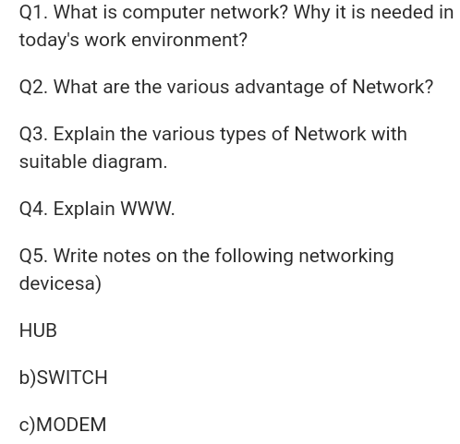

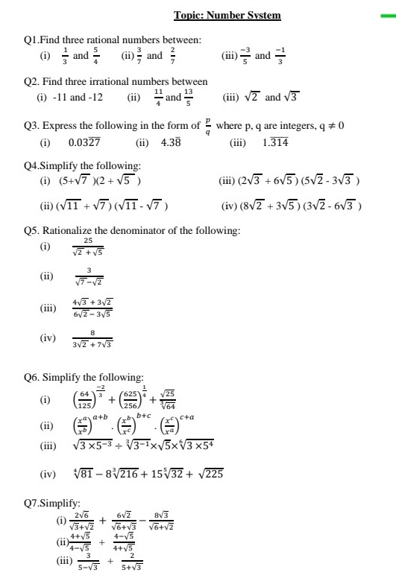
SUBJECT – MATHS

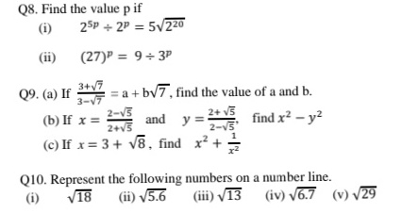

SUBJECT – S.ST
SUBJECT - HISTORY

Chapter-1: The French Revolution
Map-1
Outline Political Map of France (For locating and labeling / Identification)
Bordeaux
Nantes
Paris
Marseilles

Chapter-2: Socialism in Europe and the Russian Revolution
Map-2
Outline Political Map of World (For locating and labeling / Identification)
Major countries of First World War
(Central Powers and Allied Powers)
Central Powers - Germany, Austria-Hungary, Turkey (Ottoman Empire)
Allied Powers - France, England, Russia, U.S. A.

Chapter-3: Nazism and Rise of Hitler
Map-3
Outline Political Map of World (For locating and labeling / Identification)
Major countries of Second World War
Axis Powers – Germany, Italy, Japan
Allied Powers – UK, France, Former USSR, USA
Territories under German expansion (Nazi Power)
Austria, Poland, Czechoslovakia (only Slovakia shown in the map), Denmark, Lithuania, France, Belgium

SUBJECT – GEOGRAPHY (Outline Political Map of India)
Chapter -1: India-Size and Location
Map-4
India-States with Capitals, Tropic of Cancer, Standard Meridian (Location and Labelling)

Chapter -2: Physical Features of India
Map-5
Mountain Ranges: The Karakoram, The Zasker, The Shivalik, The Aravali, The
Vindhya, The Satpura, Western & Eastern Ghats

Map-6
Mountain Peaks – K2, Kanchan Junga, Anai Mudi
Plateau - Deccan Plateau, Chotta Nagpur Plateau, Malwa Plateau

Map-7
Coastal Plains - Konkan, Malabar, Coromandal & Northern Circar (Location and Labelling)
Chapter -3: Drainage
Map-8
Rivers: (Identification only)
o The Himalayan River Systems-The Indus, The Ganges, and The Satluj
Map-9
o The Peninsular rivers-The Narmada, The Tapi, The Kaveri, The Krishna, The Godavari, The Mahanadi
Map-10
Lakes: Wular, Pulicat, Sambhar, Chilika

Chapter - 4: Climate
Map-11
Areas receiving rainfall less than 20 cm and over 400 cm (Identification only)

Chapter - 5: Natural Vegetation and Wild Life
Map-12
Vegetation Type: Tropical Evergreen Forest, Tropical Deciduous Forest, Thorn
Forest, Montane Forests and Mangrove- For identification only
Map-13
National Parks: Corbett, Kaziranga, Ranthambor, Shivpuri, Kanha, Simlipal & Manas
Map-14
Bird Sanctuaries: Bharatpur and Ranganthitto
Wild Life Sanctuaries: Sariska, Mudumalai, Rajaji, Dachigam (Location and Labelling)

Chapter - 6: Population (Location and Labelling)
Map-15
The state having highest and lowest density of population
The state having highest and lowest sex ratio.
Largest and smallest state according to area.
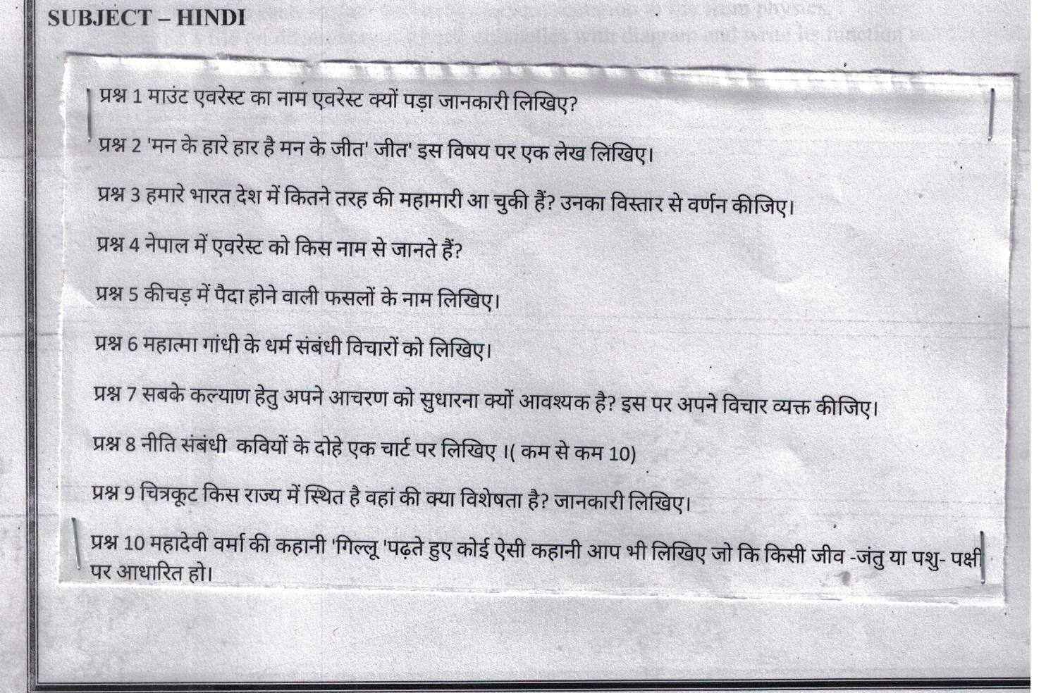
SUBJECT – HINDI

